Name _________________________________________________
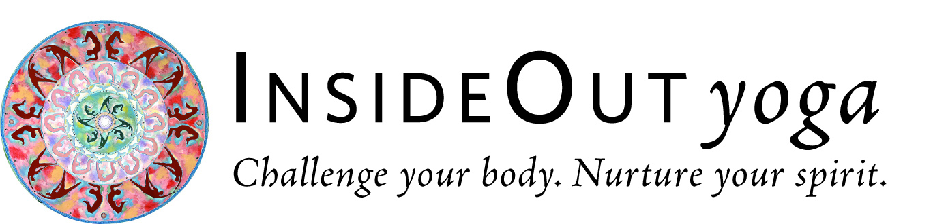
30-DAY PLANKS & POSES CHALLENGE
JANUARY 1-30, 2019

SUNDAY | MONDAY | TUESDAY | WEDNESDAY | THURSDAY | FRIDAY | SATURDAY
30  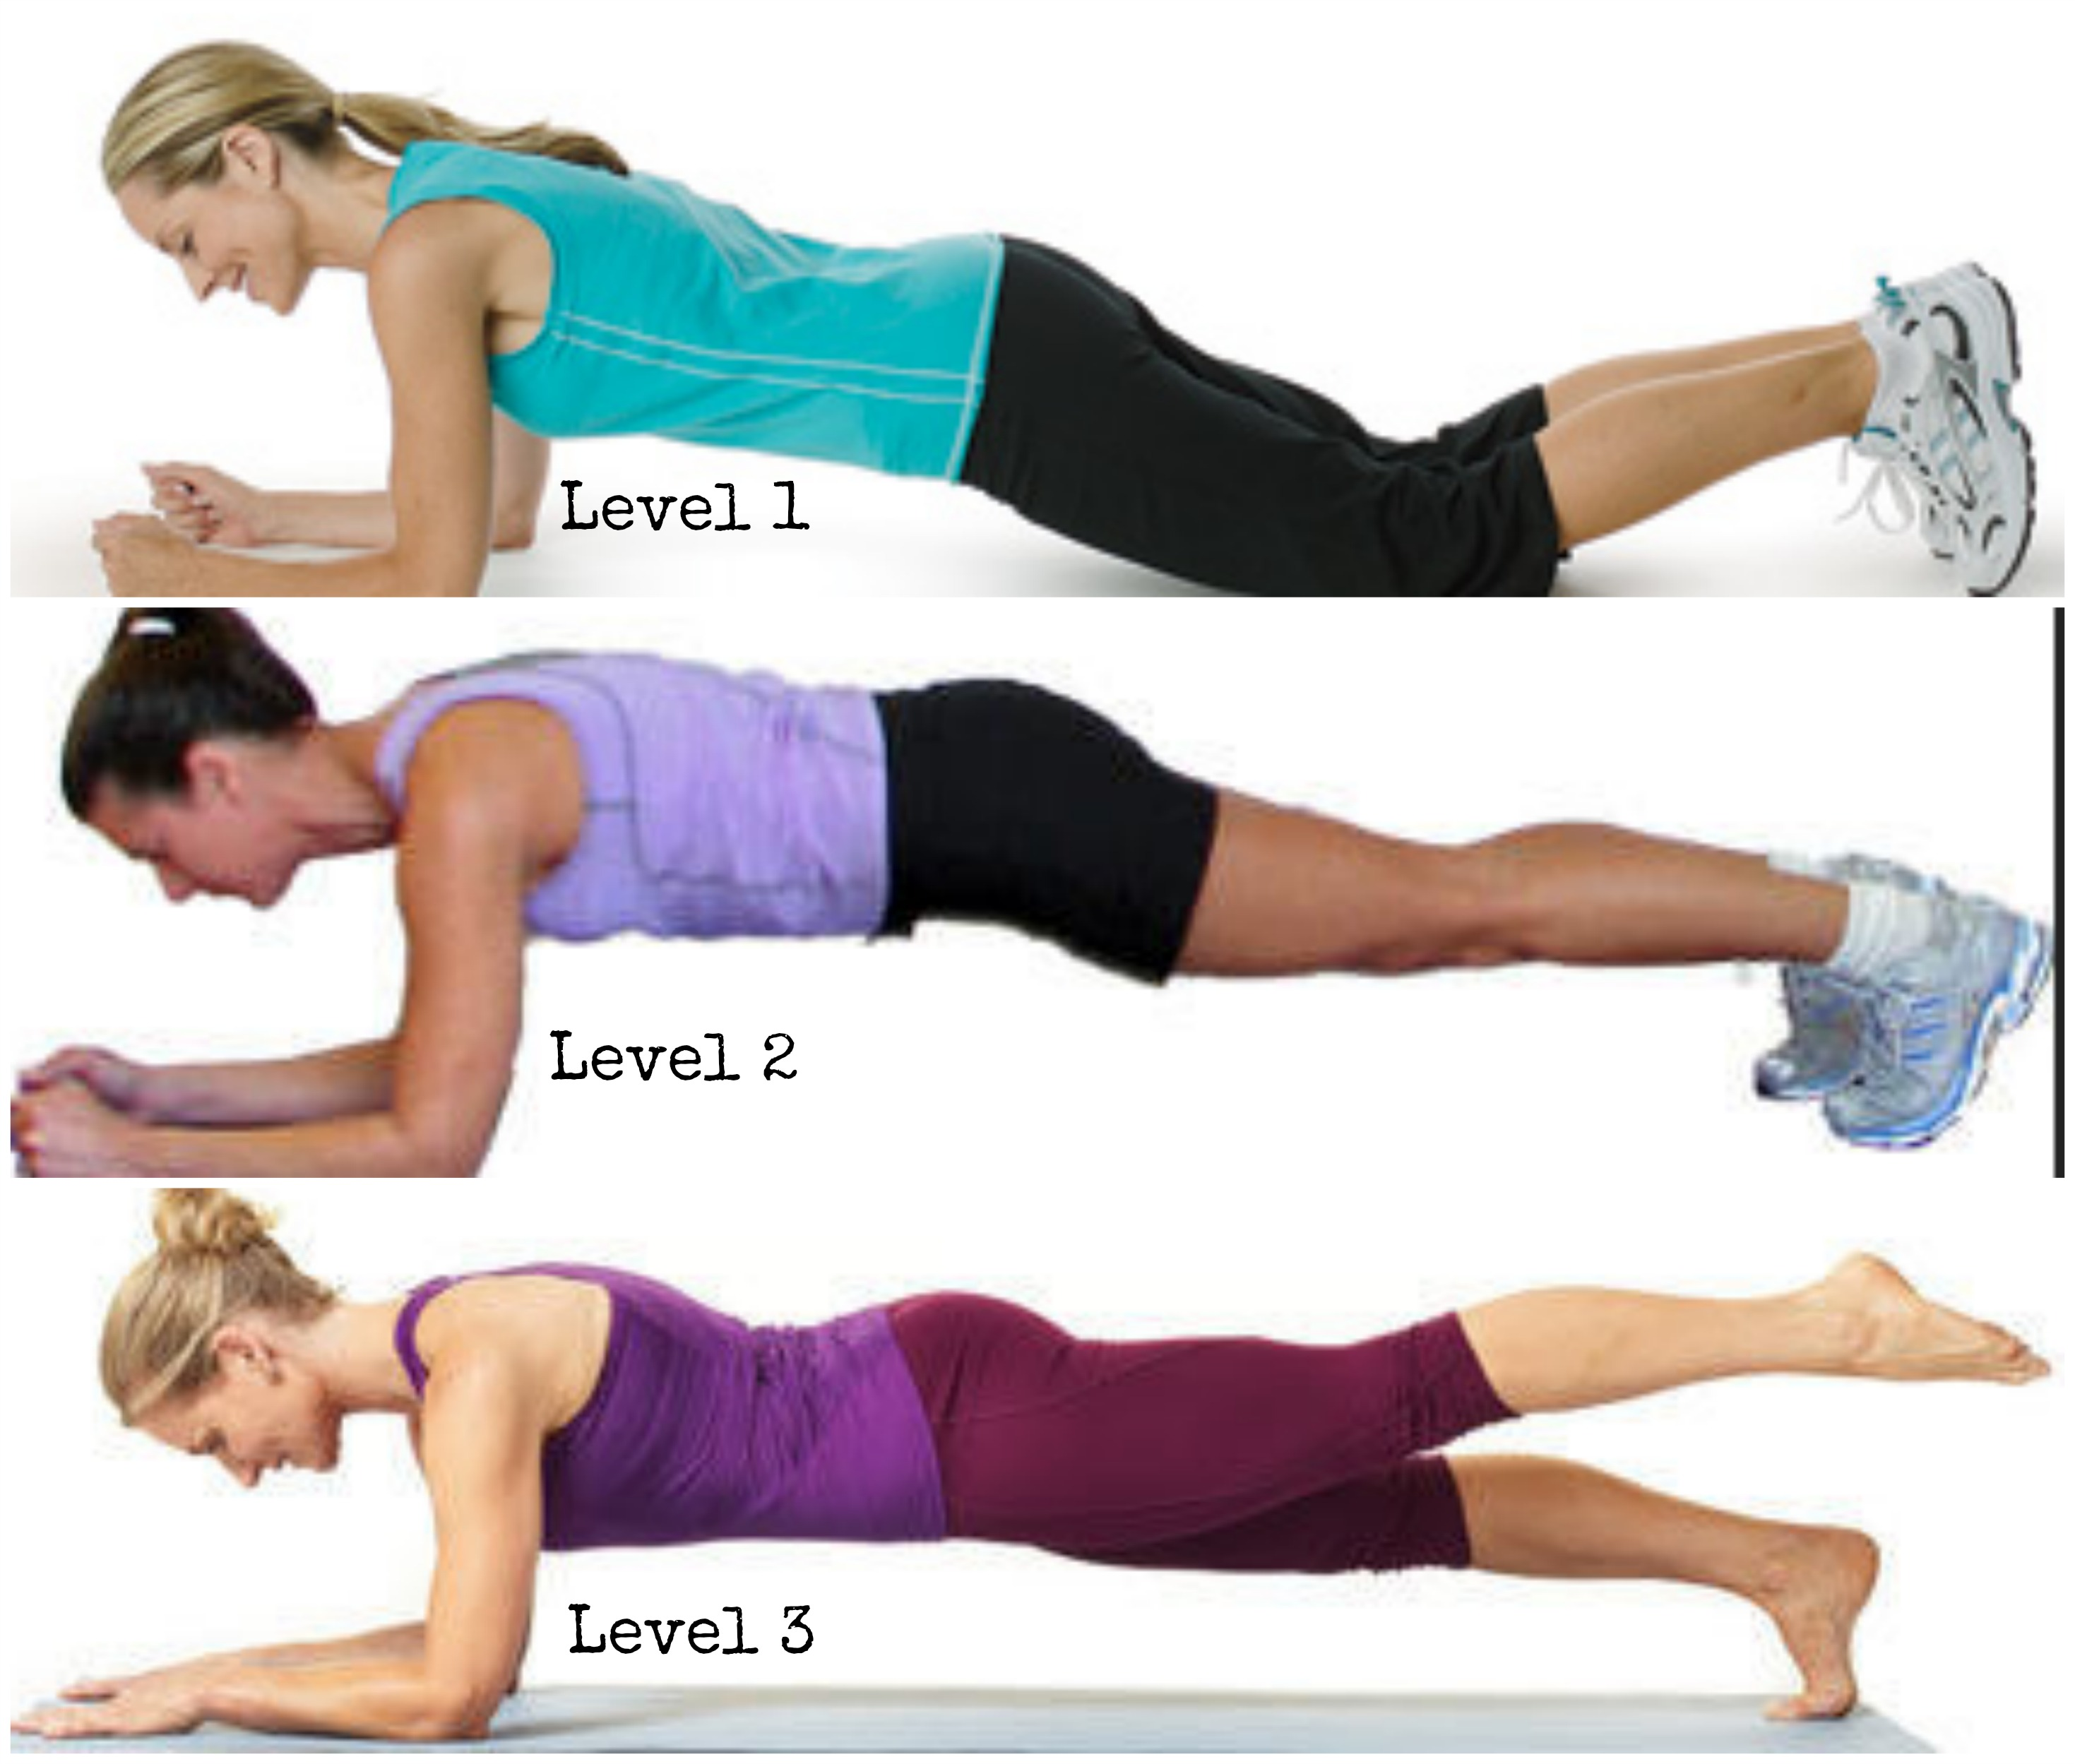 | 31  HAVE FUN! SMILE! YOU CAN DO THIS!! | 1  • Forearm Plank 20 sec  • 5 full conscious  breaths | 2  • Forearm Plank 20 sec  • An IOY class or  5-10 Sun Salutations | 3  • Forearm Plank 30 sec  • An IOY class or  5-10 Sun Salutations | 4  • Forearm Plank 30 sec  • An IOY class or  30-60 sec in a balance pose that challenges you | 5  • Forearm Plank 40 sec  • 5-10 Sun Salutations
6  • NO PLANK  • 5-10 Sun Salutations | 7  • Forearm Plank 45 sec  • 5 full conscious  breaths | 8  • Forearm Plank 45 sec  • An IOY class or 5-10 Sun Salutations | 9  • Forearm Plank 1 min  • An IOY class or  Utkatasana (Chair Pose) for 30-60 sec | 10  • Forearm Plank 1 min  • An IOY class or  5-10 Sun Salutations | 11  • Forearm Plank 1 min  • An IOY class or  30-60 sec in a balance pose that challenges you | 12  • Forearm Plank 1 min + Side Forearm Plank 20 sec ea side  • IOY Core Workshop or 5-10 Sun Salutations
13  • NO PLANK  • 5-10 Sun Salutations | 14  • Forearm Plank 1 min + Side Forearm Plank 30 sec ea side  • 7 full conscious  breaths | 15  • Forearm Plank 1 min + Side Forearm Plank 40 sec ea side  • An IOY class or  5-10 Sun Salutations | 16  • Forearm Plank 1 min + Side Forearm Plank 45 sec ea side  • An IOY class or  Virabhadrasana A  (Warrior I Pose) for 30-60 sec | 17  • Forearm Plank 1 min + Side Forearm Plank 45 sec ea side  • An IOY class or  5-10 Sun Salutations | 18  • Forearm Plank 1 min + Side Forearm Plank 1 min ea side  • An IOY class or  30-60 sec in a balance pose that challenges you | 19  • NO PLANK  • 5-10 Sun Salutations
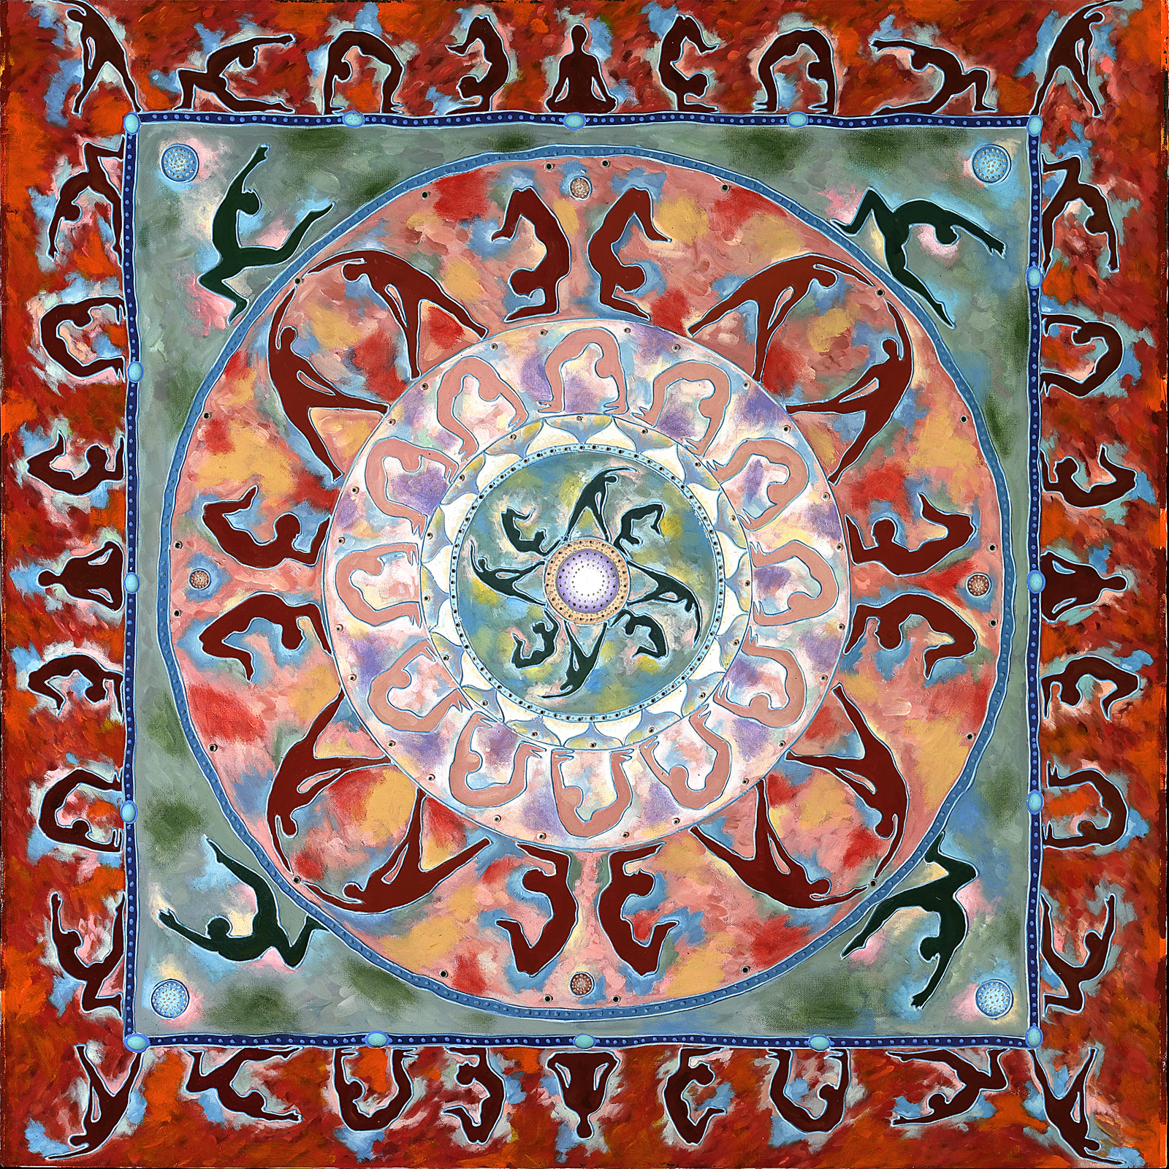  20  • Forearm Plank 1 min + 1-Legged Forearm Plank 20 sec ea leg  • 5-10 Sun Salutations | 21  • Forearm Plank 1 min + 1-Legged Forearm Plank 20 sec ea leg  • 8 full conscious  breaths | 22  • Forearm Plank 1 min + 1-Legged Forearm Plank 30 sec ea leg  • An IOY class or 5-10 Sun Salutations | 23  • Forearm Plank 1 min + 1-Legged Forearm Plank 40 sec ea leg  • An IOY class or  Navasana (Boat  Pose) for 30-60 seconds | 24  • Forearm Plank 1 min + 1-Legged Forearm Plank 45 sec ea leg  • An IOY class or 5-10 Sun Salutations | 25  • Forearm Plank 1 min + 1-Legged Forearm Plank1 min ea leg  • An IOY class or  5-10 Sun Salutations | 26  • NO PLANK  • 5-10 Sun Salutations
27  • Forearm Plank 1 min + Straight-Armed Bird Dog Plank 5 sec ea side  • 5-10 Sun Salutations | 28  • Forearm Plank 1 min + Straight-Armed Bird Dog Plank 10 sec ea side  • 10 full conscious  breaths | 29  • Forearm Plank 1 min +Straight-Armed Bird Dog Plank 15 sec ea side  • An IOY class or  5-10 Sun Salutations | 30  • Plank 1 min + Straight-Armed Bird Dog Plank 15 sec ea side  • An IOY class or  5-10 Sun Salutations | 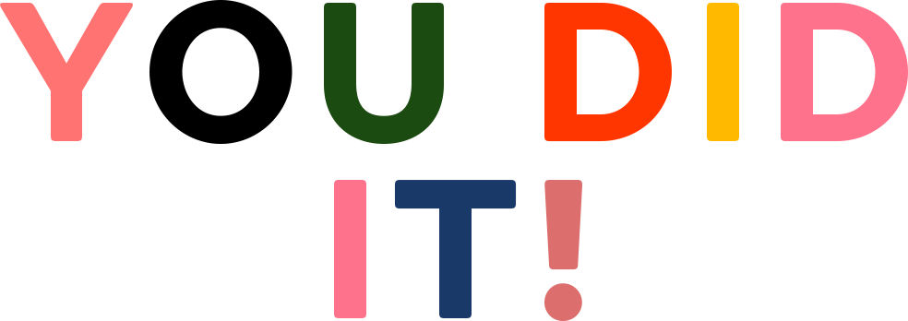 | 29  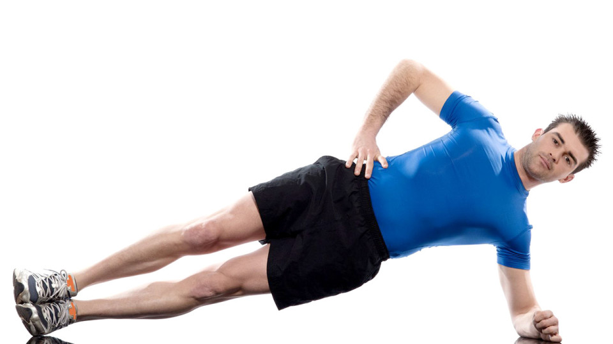 | 30  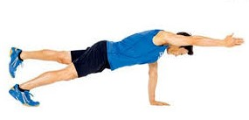

- Everyone who completes the challenge gets a free class and will be put in a drawing for an 8-class pass!

- Time and variations of planks & poses are up to you!! Stay as long as you can with good form, modifying as needed to avoid injury. Please note your time in the calendar.

- Other than in Breathe & Stretch, we will do the plank variation for the amount stated on this calendar in class that day.

- Here’s a video with great instruction for optimal alignment in plank. Do the whole 20 min or fast forward to 8.30 to get right to the plank instructions.

- Sun Salutations can be whatever type you wish: ½ Sun Salutations, Surya Namaskar A, Surya Namaskar B, Lunge Salutations, etc. I suggest you mix them up.

- Calendars must be received (either emailed or at IOY) by February 4 to be eligible for free class and drawing - sorry, no exceptions.

- Free class must be used by March 1, 2018. 8-class pass expires 1 year from first class used. Sorry, no exceptions.

- Drawing will take place at Dinner & a Movie, Friday, February 22, 6:30-8:30 pm. Need not be present to win.

